INTERNAL COMPONENT& WORKING FLOW

INTRODUCTION
A plasma lighter (also called an arc lighter) creates an electric plasma arc instead of a flame. Below is a clear breakdown of its internal components and how it works step by step.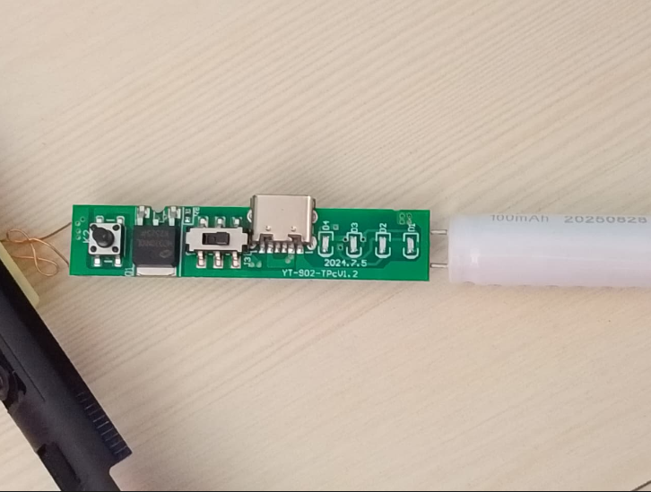

1. Main Internal Components

1. Rechargeable Battery
- Usually a 3.7V lithium-ion or lithium-polymer battery
- Stores energy for arc generation
- Charged via USB (Type-A, Micro-USB, or USB-C)

2. Charging Circuit
- Regulates safe charging of the lithium battery
- Protects against:
  - Over-charging
  - Over-discharging
  - Short circuits
- Often includes charge indicator LEDs

3. Power Control Button / Touch Sensor
- User interface to activate the lighter
- Sends a signal to the control circuit
- Some models use capacitive touch instead of a mechanical button

4. Control & Oscillator Circuit (PCB)
- The “brain” of the lighter
- Functions:
  - Converts low-voltage DC to high-frequency AC
  - Controls arc duration (auto-off safety, usually 5–10 seconds)
- Typically uses:
  - Transistors or MOSFETs

5. Step-Up Transformer (High-Voltage Transformer)
- Raises voltage from ~3.7V to several thousand volts
- Operates at high frequency (kHz range)
- Essential for creating plasma between electrodes

6. Electrodes (Arc Tips)
- Usually two or four metal electrodes
- Made from heat-resistant conductive alloys
- Spaced closely to allow arc formation
- Plasma arc temperature can exceed 1000–2000°C

7. Protective Casing & Insulation
- Heat-resistant plastic or metal shell
- Insulates user from high voltage
- Prevents accidental contact with electrodes

2. Working Flow (Step-by-Step Operation)

Step 1: Activation
- User presses button or touches sensor
- Control circuit wakes up

Step 2: Power Conversion
- Battery supplies low-voltage DC
- Oscillator circuit converts DC → high-frequency AC

Step 3: Voltage Boosting
- AC current flows into step-up transformer
- Voltage increases to thousands of volts
- Current remains very low (safe but powerful)

Step 4: Plasma Arc Formation
- High voltage jumps across electrode gap
- Air molecules ionize → plasma arc
- Visible purple/blue electric arc appears

Step 5: Ignition
- Arc provides extreme localized heat
- Instantly ignites:
  - Paper
  - Cigarettes
  - Candles
  - Thin wood shavings

Step 6: Auto Shut-Off
- After preset time (or button release):
  - Circuit cuts power
  - Arc extinguishes
- Prevents overheating and battery drain

3. Simplified Flow Diagram (Text)
Battery (3.7V DC)
↓
Control / Oscillator Circuit
↓
High-Frequency AC
↓
Step-Up Transformer
↓
High Voltage (kV range)
↓
Electrodes
↓
Plasma Arc (Heat)

Plasma Lighter – Work Flow Diagram
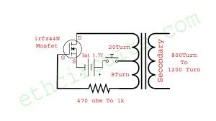

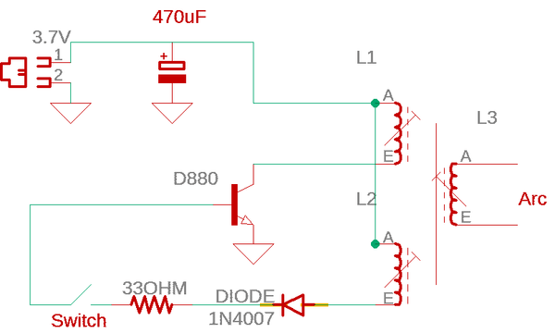

Simple Text-Based Work Flow Diagram
[User Presses Button / Touch Sensor]
↓
[Control Circuit ON]
↓
[Battery (3.7V DC Power)]
↓
[Oscillator / Switching Circuit]
(DC → High-Frequency AC)
↓
[Step-Up Transformer]
(Low Voltage → High Voltage)
↓
[High-Voltage Output]
↓
[Electrodes (Small Gap)]
↓
[Air Ionization]
↓
[Plasma Arc]
↓
[Ignition]

